11/21/2025

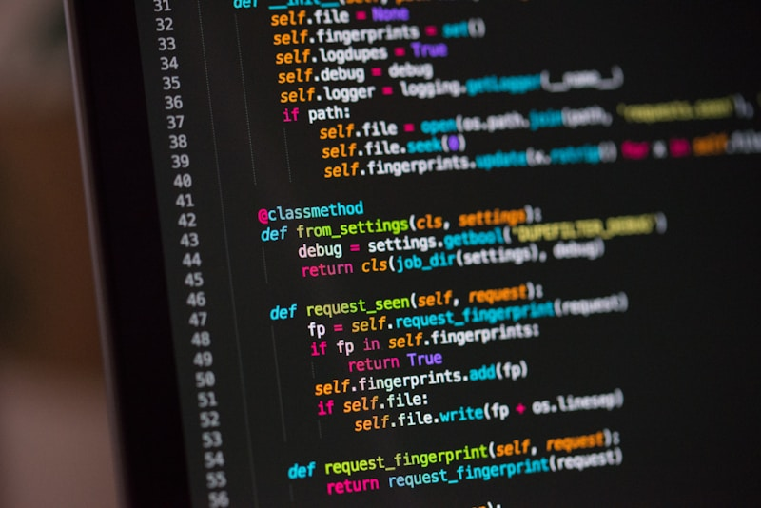
A Guide to understand the coding realm
The best coding languages and acting platforms
Kelebogile Gopane
What is coding?
Coding is a process or skill of written instructions that is required to design and develop computer programs, software applications and webpages.

What is a coding language?
A coding language is a programming language used to communicate with a computer and instruct it to perform specific tasks. Each programming language has its own syntax (grammar and rules) when typing the code which gets translated into a format the computer can produce.

LIST OF THE BEST CODING LANGUAGES
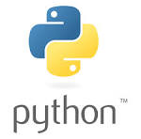
Python
A high level and versatile programming language known for its ease of use and understanding which makes it an excellent choice for beginners and experienced developers

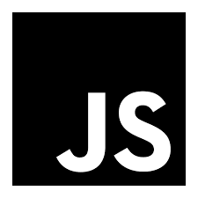

JavaScript
A programming language that allows the developer to apply complex features on webpages such as 2D or 3D animate graphics, digital maps that let you do more than looking at a static picture. E.g. Zoom in and out, click, hover around and drag.

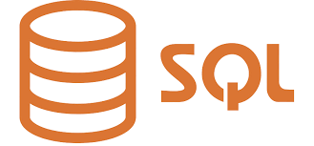
SQL (Structured Query Language)
A standard, domain specific programming language that is used to manage and manipulate organized data stored in databases. It is the best tool used for defining the data structure, extracting specific information and managing the access of the user within the database systems.
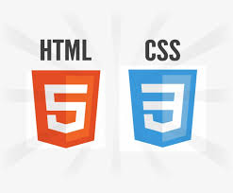
HTML and CSS
HTML (Hyper Text Markup Language) provides the basic structure and interpretive meaning of a webpage while CSS (Cascading Style Sheets) controls the style and appearance of the existing structure created by HTML. It allows developers to apply style to specific HTML elements, giving the website a visually appealing and flexible design.

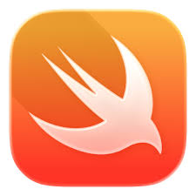
Swift
A multi-purpose, assembled and versatile programming language developed by Apple to emphasize safety, performance and modern software design. It is used to build and create applications (apps) for the entire Apple Network such as IOS, MacOS and WatchOS but it is also an open source software that provides support for the development of Linux and Windows.
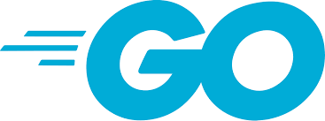
GO
An open source, resourceful building tool programming language designed by Google for programmers and developers to be more productive for the large scale software development. Recognized for having a clean syntax, being efficient, easy to interpret and having a built in support for communication and synchronizing channels for high performance.

BEST CODING LANGUAGE FOR THE FOLLOWING:
Web Design | Python  JavaScript  HTML and CSS
App Design | Swift  GO
Text Formatting | HTML and CSS  Python  JavaScript
Creating Databases | SQL

BEST ACTING PLATFORM FOR THE CODING LANGUAGE
Python | Xoscar  Pycharm  DJango  Udemy
JavaScript | VS code  Webstorm  JSFiddle  CodePen
SQL | MySQL  SQLite  Oracle Database  Microsoft SQL server
Swift | ACTOR  Swift 5.5
Go | Go-actor  GoAKT  Ergo Framework

